**Creating User and Group Accounts**

**Objective:** To create user and group accounts to add the users to the Azure subscription

**Tools Required:** None

**Prerequisites:** None

Steps to be followed:

1. Add a new user
2. Create a new group and add members

**Step 1: Add a new user**

* 1. **Sign in** to the Azure portal as a user administrator and go to the **Azure active directory**

* 1. Select **Users**, click on **New user**, and then click on **Create new user**

* 1. Enter the necessary details of the user. Then, click on **Next: Properties >**

* 1. Click on **Next: Assignment**

* 1. Then, select **Next: Review + Create**

* 1. Next, click on **Create**

The output appears as follows:

**Step 2: Create a new group and add members**

* 1. On the **Azure Active Directory** page, select **Groups**

* 1. Click on **New group** and provide a group name

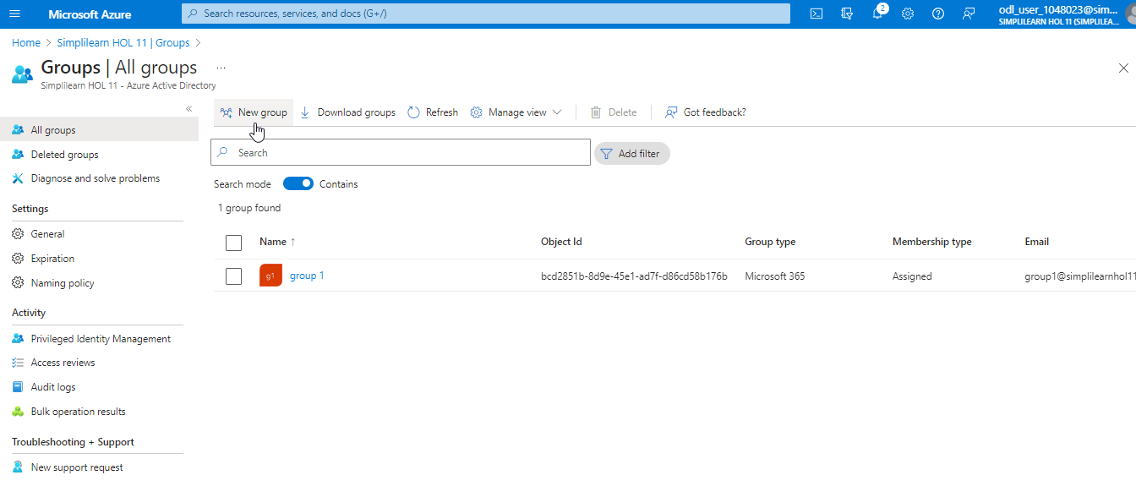

* 1. Choose the group type and click on **create**

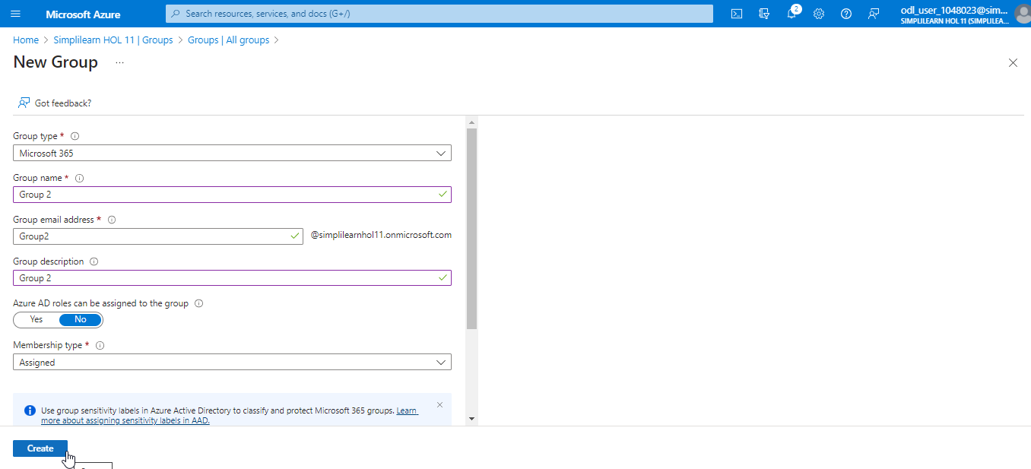

The **Group2** is created as shown below:

* 1. Select **Members** from the **Groups** page

* 1. Click on **Add Members**

* 1. Select the user, and then click on the **Select** button

The final output is shown as below:

You have now successfully added the users to the Azure subscription, created groups, and assigned users to these groups.